Travelling by Train
Through Japan

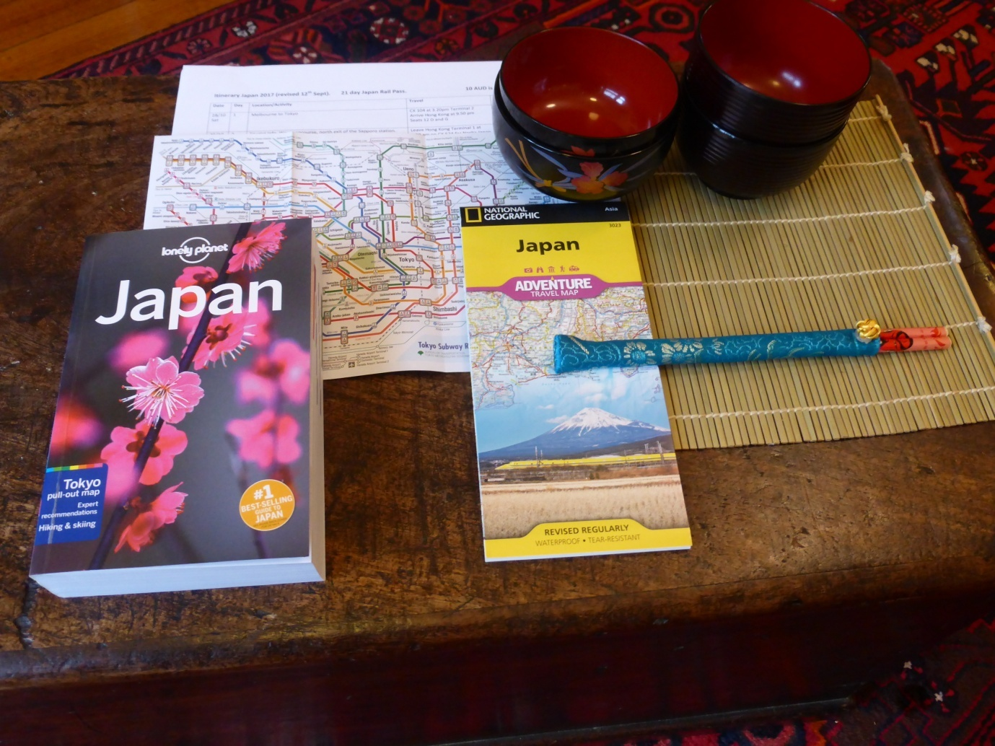

The Rotary Club of Canterbury “Let’s Stay Connected Project” has been developed as a response to an identified need within the Aged Care sector.
At times when it’s difficult to connect in person with family and friends, the Rotary Club of Canterbury has pleasure in offering you this booklet, designed to promote conversation, recollection and engagement for those who are in isolation and without their usual social activities.
The booklets have been designed for people in an aged care residence, village or at home to read by themselves, or to have a family or staff member share the booklet with them.
You can download this and other booklets from the Rotary Club of Canterbury website (www.canterburyrotary.org).
Source references for this book are held at the Rotary Club of Canterbury. Contact president@caterburyrotary.org for further details.
Material in this book was reproduced in accordance with Section 113F of the Copyright Act (1968).

Hello or Konnichiwa
In 2017, my husband and I travelled by train throughout Japan. Train travel in Japan is efficient and very comfortable. There are always people to help if you are confused.
This booklet recounts just some of the different places we visited and the places we saw, stayed in, what we ate and explored. I hope you will enjoy reading about a few of our adventures.

Caroline and Roger
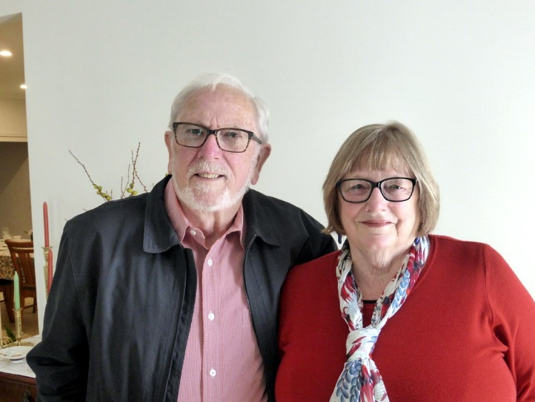

Our Itinerary
It was our third trip to Japan; a country we find fascinating because it is so different from Australia. We travelled from Sapporo in the north to Hiroshima in the south.
This sketch map shows the cities and towns we visited and the main train trips.
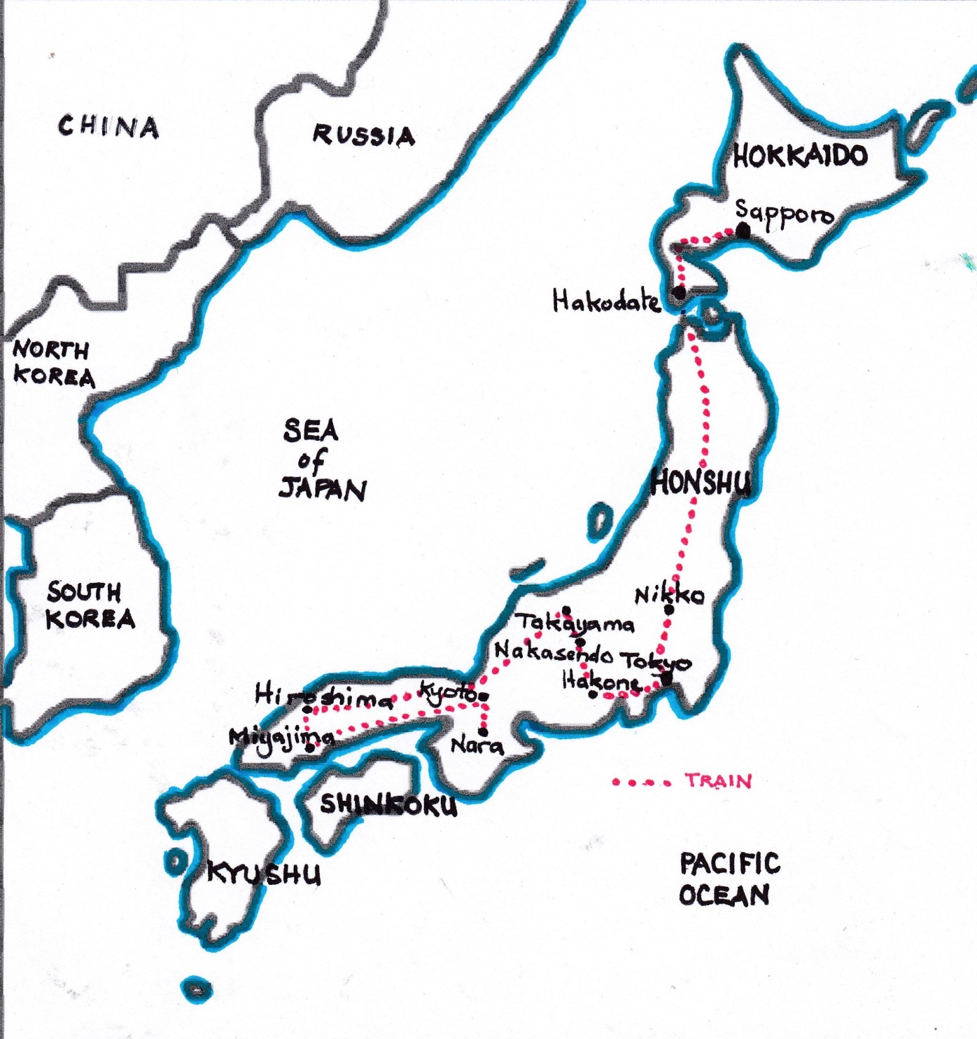
Sapporo
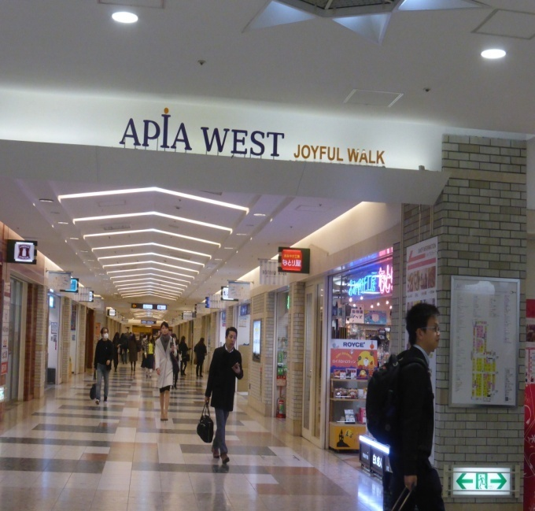
Our first stop was Sapporo on the northern island of Hokkaido. It was bitterly cold, but we still went exploring-underground! You can travel right across the city via underground malls. These malls have shops, train stations, cinemas, hotels and markets.

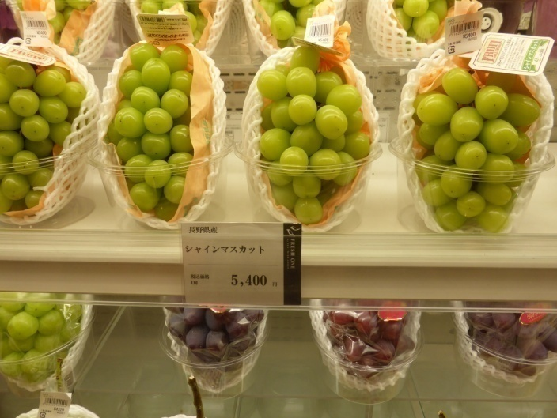
The grapes were very expensive as they were imported. Each package shown on the right cost the equivalent of $65.00.

Sapporo
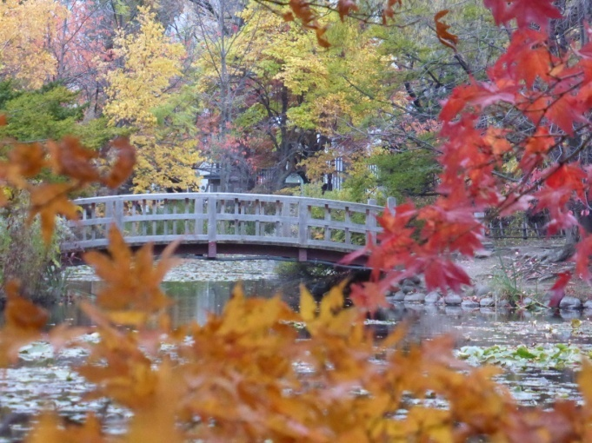
It was autumn and everywhere the trees were showing bright autumn colour. All the street trees and the trees in the parks were red, gold and bronze.

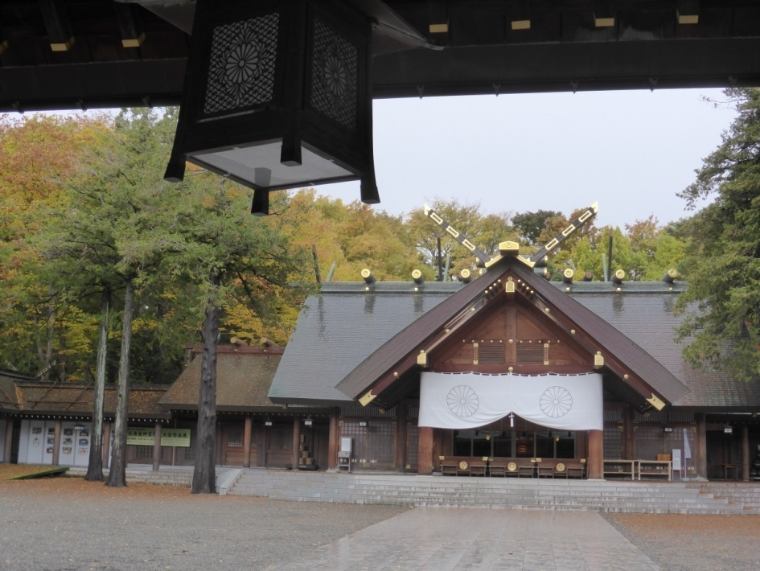
Our first adventure was travelling by train to a temple. No-one spoke English! When the train arrived at the village, it was snowing so rather than walk we caught a taxi to the temple.
Sapporo
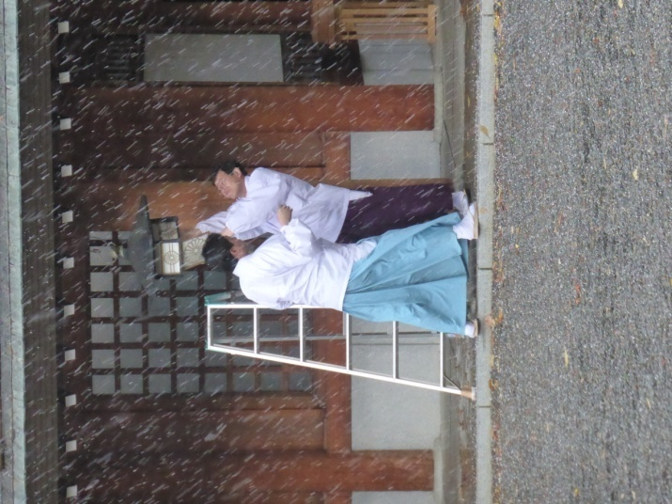
The photo shows two priests trying to fix a lantern whilst it was snowing.

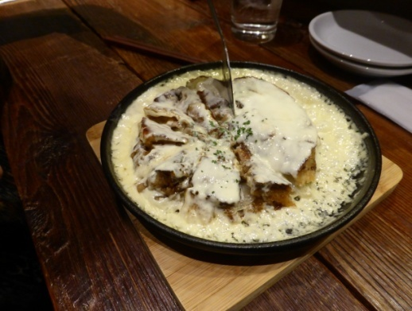
For dinner that night we found a small restaurant near our hotel which served ‘okonomiyaki’.

This dish is like a pancake stuffed with vegetables. Ours also had cheese sauce. It was delicious. It was Japanese with a French influence.
Hakodate
Hakodate lies on the southern tip of the island of Hokkaido. Have a look on the map.

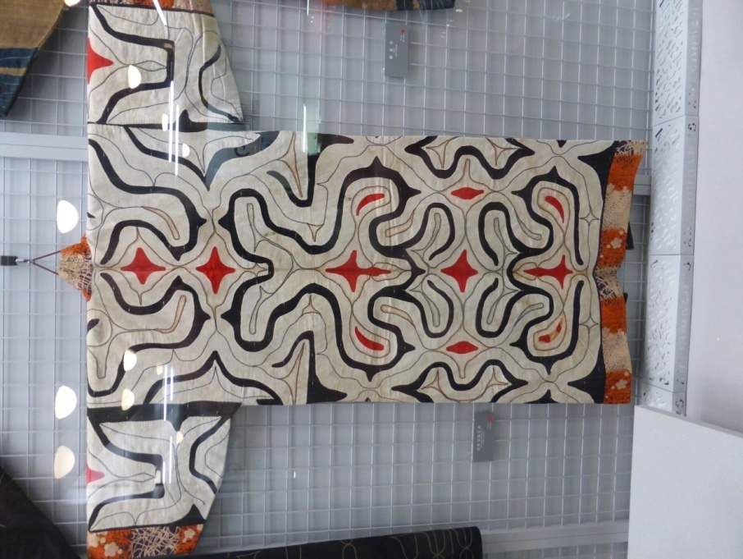
The first adventure here was trying to find the Museum of Northern Peoples. The Ainu are to Japan what the Aborigines are to Australia. Eventually we found it after travelling on a tram, a taxi and walking! The museum had interesting artefacts from the Ainu people including a collection of intricately patterned garments.
Hakodate
In the afternoon we travelled to a fort. This time we didn’t get lost! It was built in 1850 and was the scene of the last battle of the Shoguns.
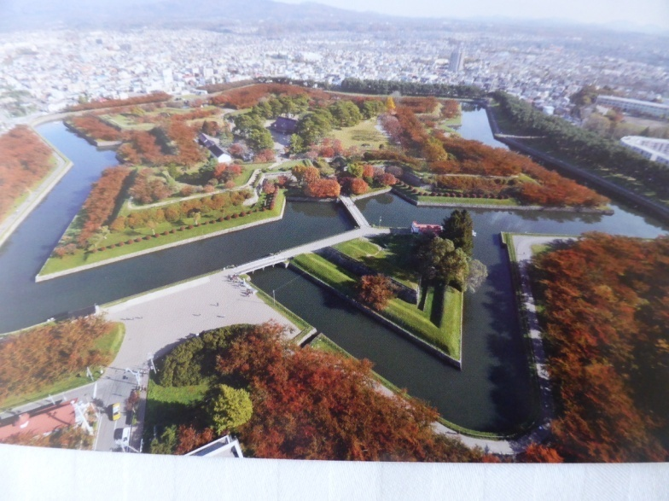
The maples were a glorious bright red.
We spent quite some time walking around the walls of the fort and admiring the trees.

Tokyo
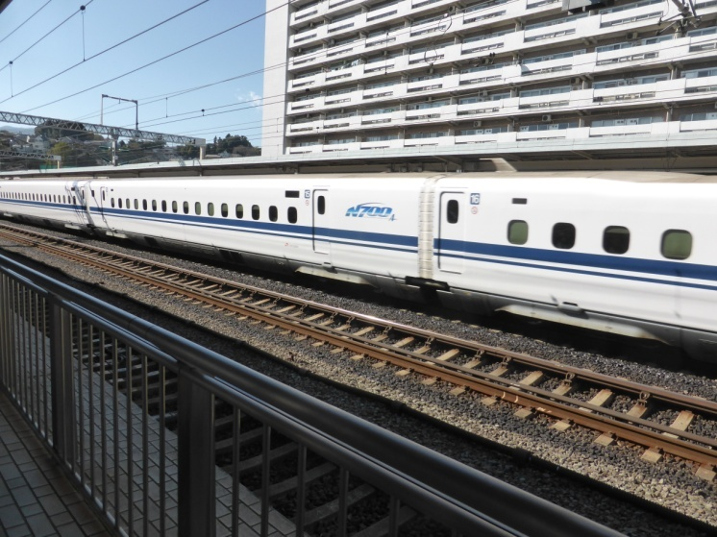
After travelling on 3 trains including the bullet train going 250 kph, we arrived in the capital of Japan, Tokyo. It is a city of over 37 million.
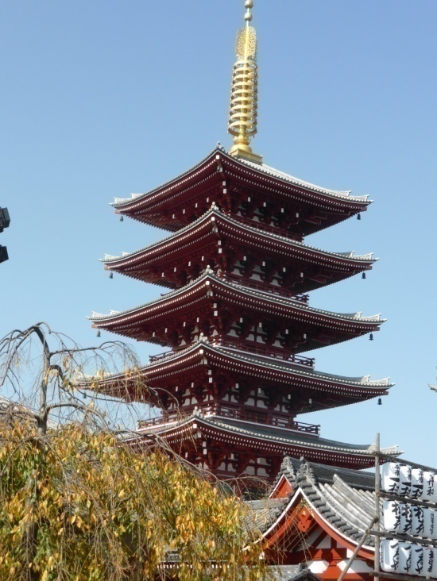
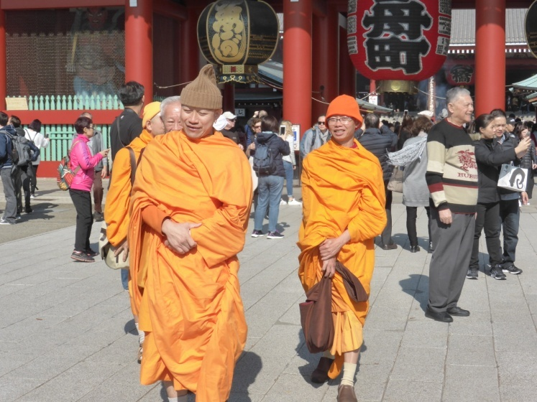
One of our favourite places in Tokyo is the Asakusa shrines and temple complex. It is easy to take lots of photos as there is so much to see. People pray, burn incense, receive blessings and eat snacks. The Japanese people love snacking. We did too!! We love steamed buns.
Nikko
About 2 hours north of Tokyo is the town of Nikko. It is a Shinto Shrine complex in a stunning mountain setting amidst towering cedars. Described as one of the most beautifully decorated shrines, it was breathtaking.
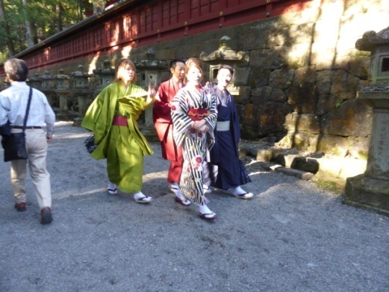
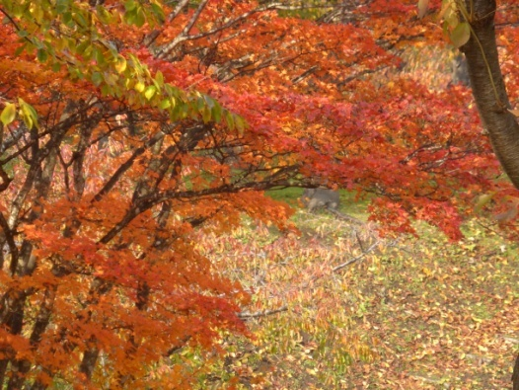

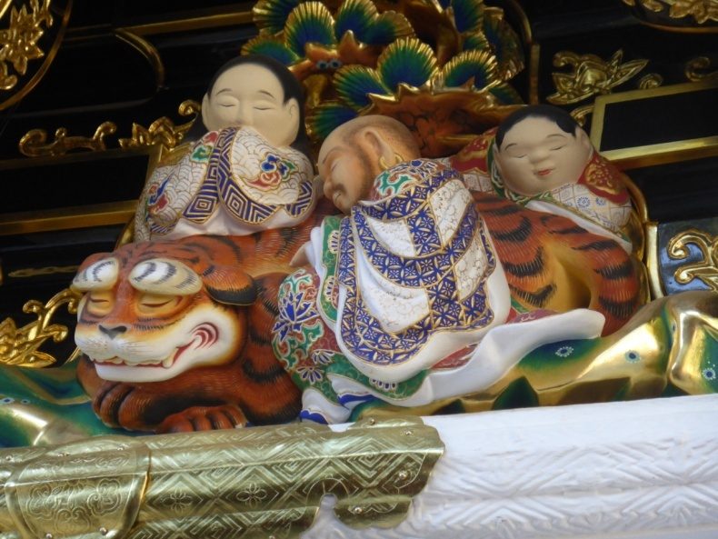

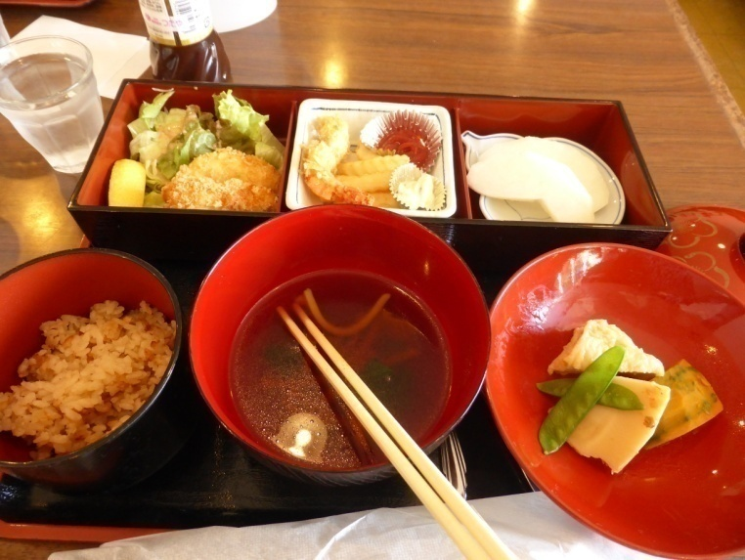
Nikko

Our lunch at Nikko was typically Japanese with rice, chicken, prawns, vegetables, a soybean curd roll, noodle soup, a salad and a nashi pear. It was very filling and we enjoyed it all. The Japanese present food so attractively.

Hakone
As a special birthday present, my husband booked a stay in an ‘onsen’ in Hakone, 2½ hours south of Tokyo. These guesthouses have natural hot springs due to volcanic activity.

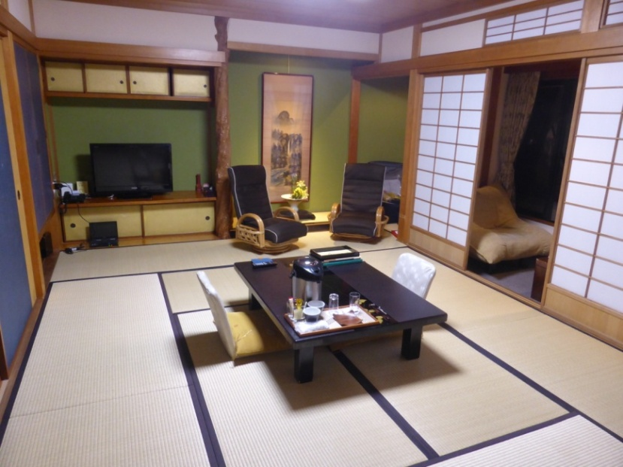
We slept on futons laid upon Japanese tatami or rolled straw mats. You must not wear shoes inside, only socks or slippers.

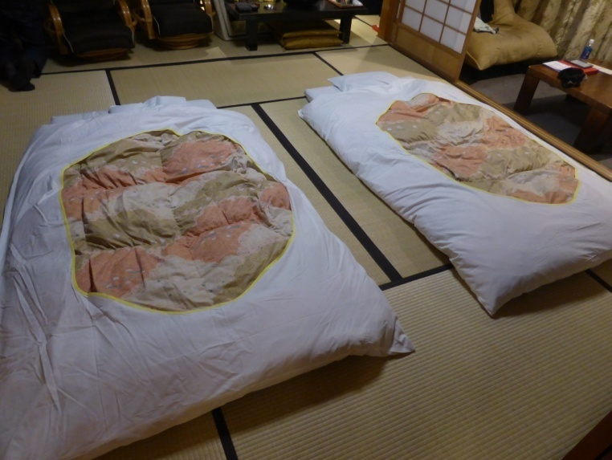
Sleeping on futons, on mats, with large soft doonas was very comfortable. It was just hard to get up! The beds were made up each evening.
Hakone – the onsen
Let me describe the setting. The men’s and women’s areas each have 4 springs, 2 indoor and 2 outdoor. The outdoor pools set amongst gardens and trees. The water is the temperature of a hot bath and gently bubbles. One night I bathed under the stars and trees.

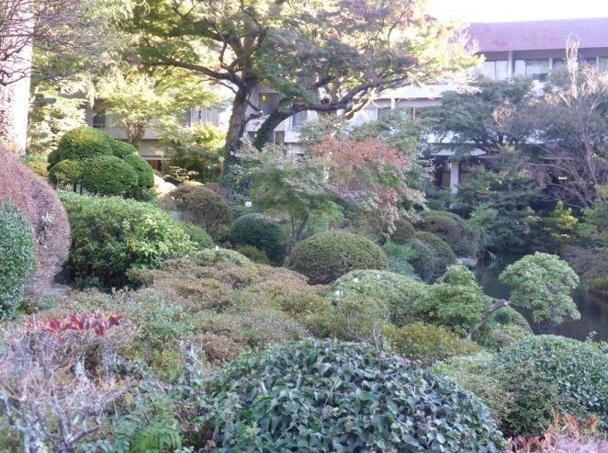
This is the gardens of our guesthouse. The garden has many azaleas which must look amazing when they are flowering.

No photos of the springs are allowed because everyone is naked. There are separate bathing areas for men and women. I was nervous and very self-conscious at first.
Hakone – the onsen
Before you enter the pools, you must clean yourself. You sit on a stool with a hand-held shower and a face washer and wash every part of you. These washing rituals are strictly enforced. No soap is permitted in the pools.

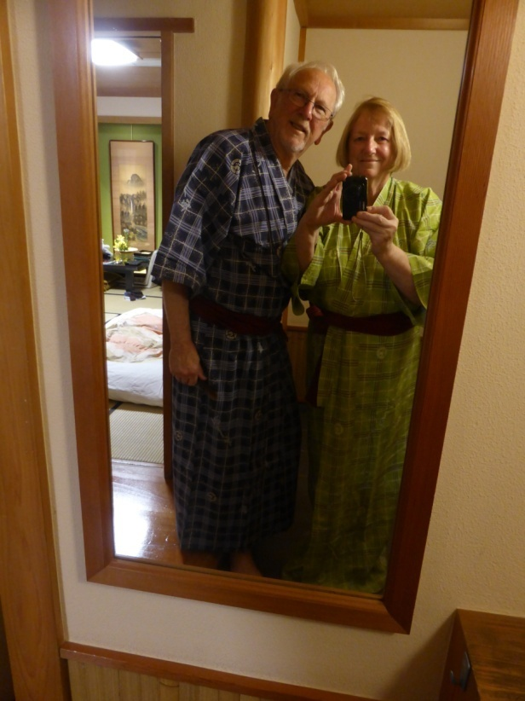
Yukata kimonos are supplied for walking to the bathing areas. You put your face washer on your head before entering the pool. There were women of all ages, sizes and shapes. After a while, you lose your self-consciousness.

We found bathing in the Japanese way in hot springs a relaxing and beautiful experience.
Hakone
Whilst in Hakone, we went on a trip over the volcanic area. We took a gondola and ‘flew‘ over the active volcanic area with billowing sulphuric steam. The smell of sulphur was overpowering. In the distance we could see the famous Mt Fuji. After the gondola, we boarded a boat and sailed around a crater lake.

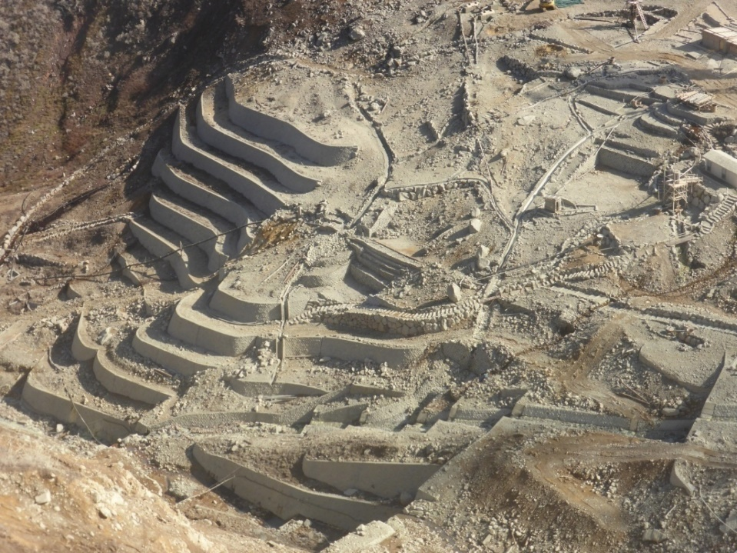

This photo is of a sulphur mine we passed over on our gondola ride. When I look at this photo, I can still smell the sulphur stench.
Kiso Valley - Nakasendo trail
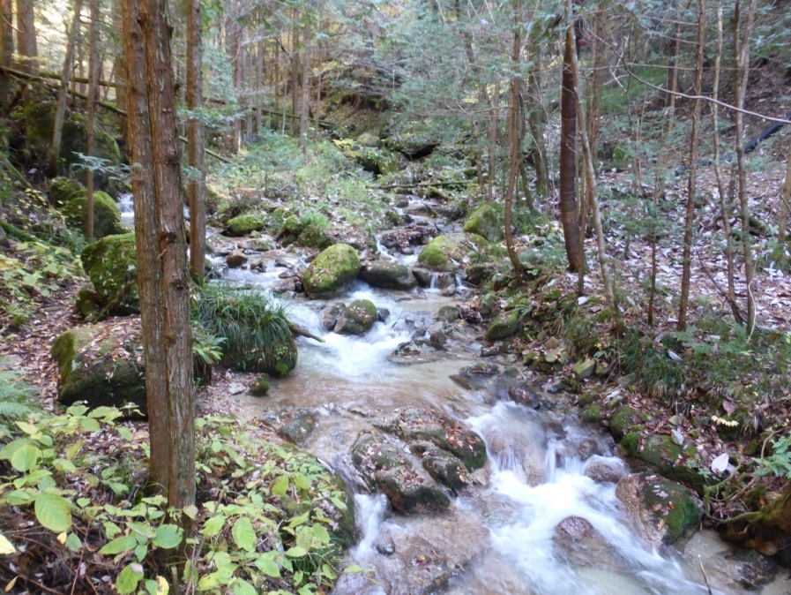
From Hakone we travelled to the Kiso Valley, to walk part of the Nakasendo trail.

This trail is part of the original trading route between Kyoto and Tokyo. There are 69 trading posts on this old route in the mountains. We walked from the 42nd to the 43rd trading villages. While this is only 8km long, it is a rough track and up and over a steep mountain. I knew my knees would hurt!
Kiso Valley - Nakasendo trail
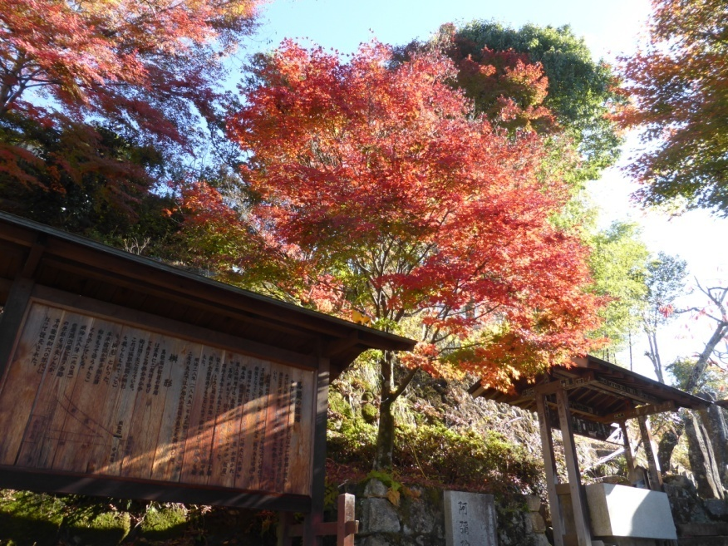
The villages at each end of our walk were picture perfect with the old cedar houses and shops, blackened with age. Along the trail, the Kiso River was our constant companion.
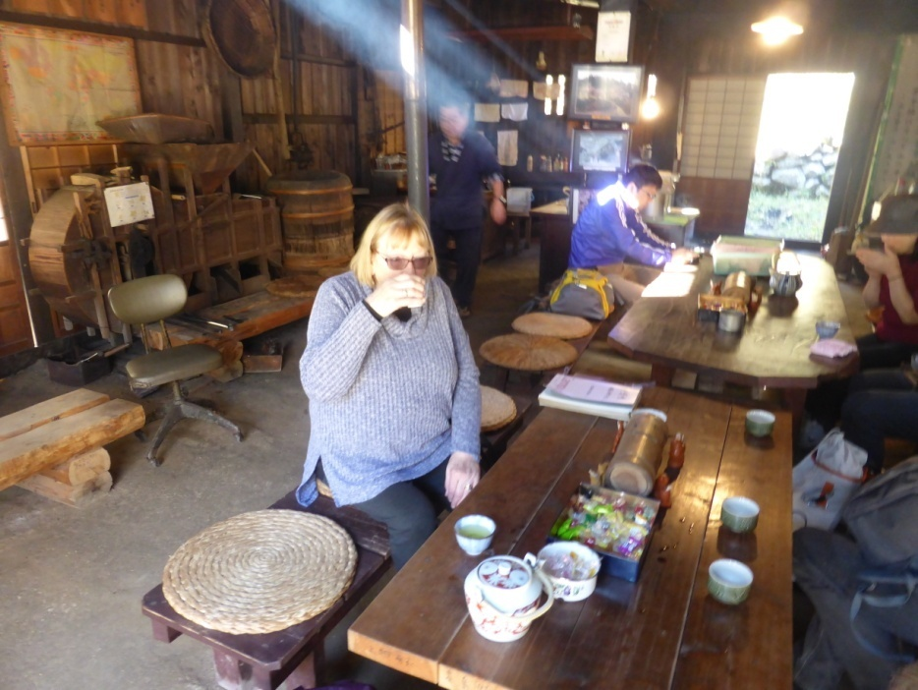
We stopped at a tea house and had a welcome cup of tea.
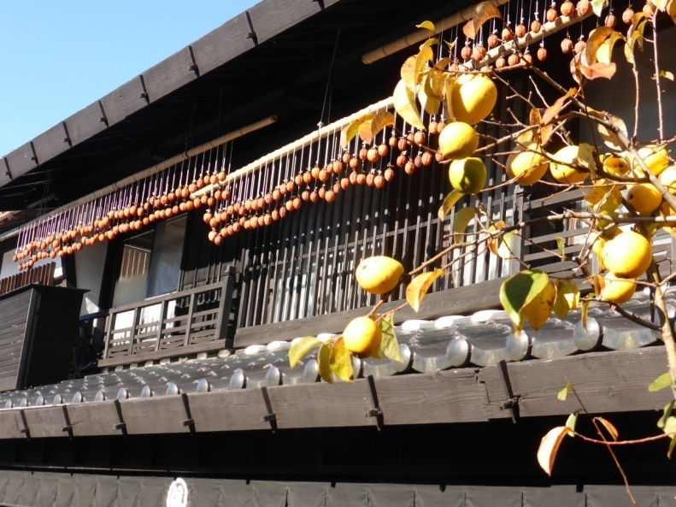
Kiso Valley - Nakasendo trail
On the houses, fruit, chillies & vegetables were hung out to dry.
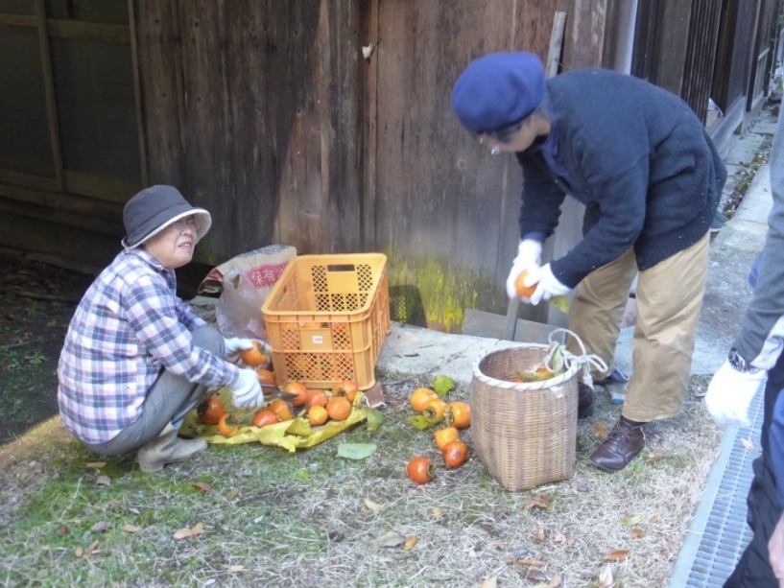

These ladies are preparing persimmons for drying.
Kiso Valley - Nakasendo trail
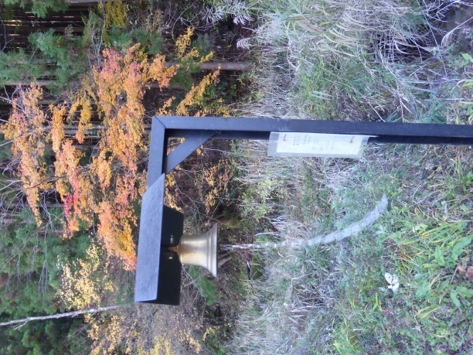
Periodically, along the trail, walkers were advised to ring the bells to scare away bears. I had read that the last bear seen on the trail had been over 20 years ago so we weren’t really scared. Despite this, we rang the bells, loudly, just in case!

Whilst the walk was quite strenuous and rather painful for the knees, we thoroughly enjoyed it and
We found the scenery entrancing.

Takayama
Our next stop was a small, delightful, well-preserved, heritage-listed town, Takayama.
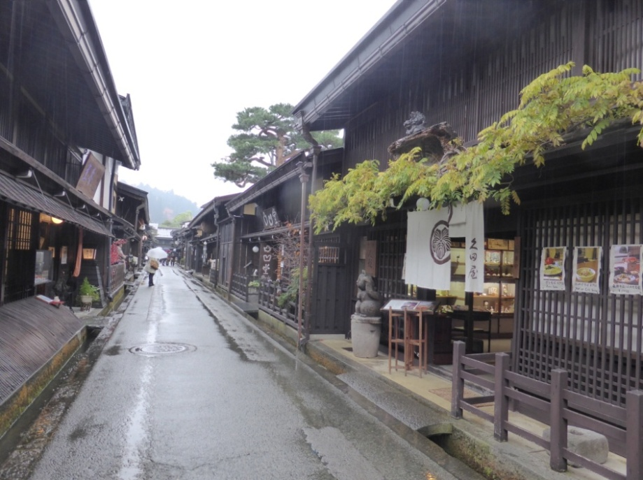
The houses and shops are all very old and made from cedar, blackened with age. It rained a lot whilst we were there but it didn’t matter.

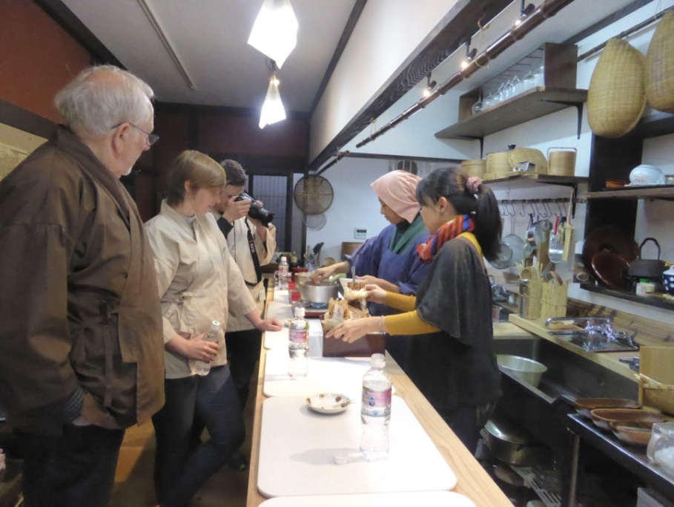
While staying in Takayama, we took a cooking class with a local lady. There were four of us learning in her kitchen. We made fresh tuna sushi, egg roll, and a chicken, mushroom and tofu hot pot.
Temple Stamps
During our trip, I collected temple stamps. At each temple we visited, a priest would write a blessing and stamp it with the temple’s red stamp.
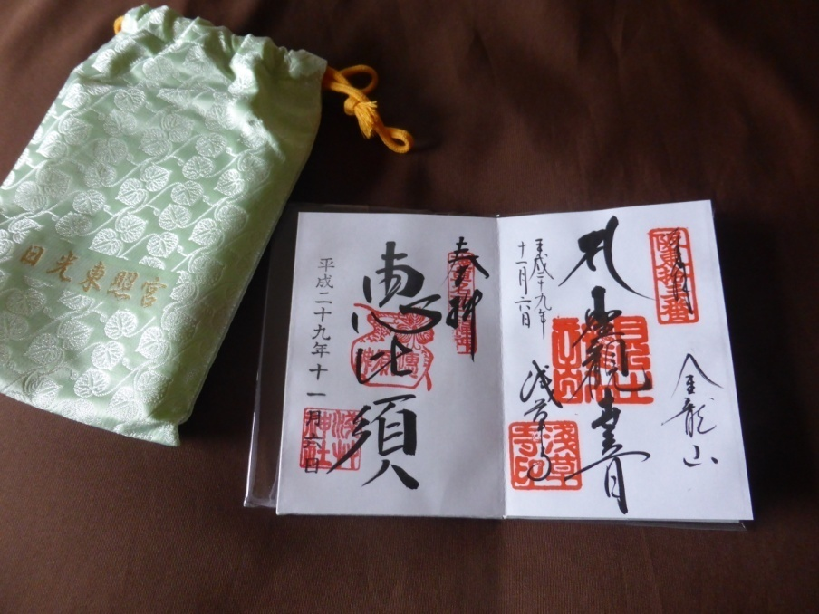
My book is open at two of the red stamps and blessings I collected in this town. The book makes an interesting souvenir. Stamp collecting is a popular pastime in Japan.

World Heritage Village
From Takayama, we took a tour to a World Heritage Village.

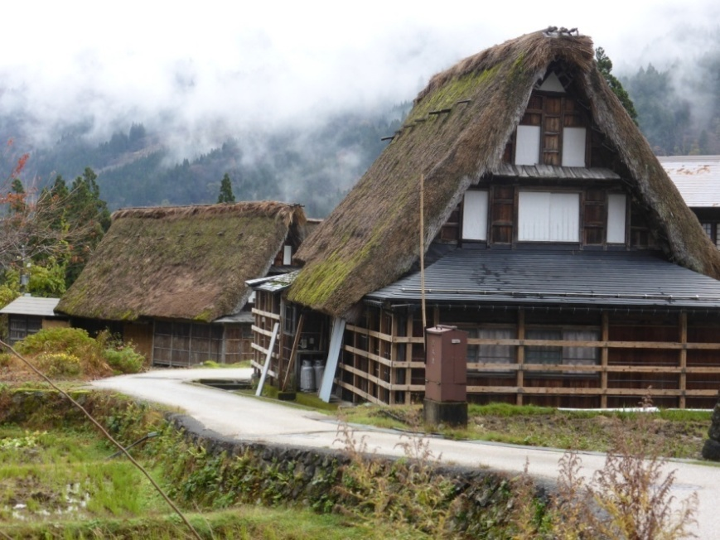
The tiny villages are in isolated valleys. Occupants live a very traditional life. Their houses are made from local materials and are thatched with grass.
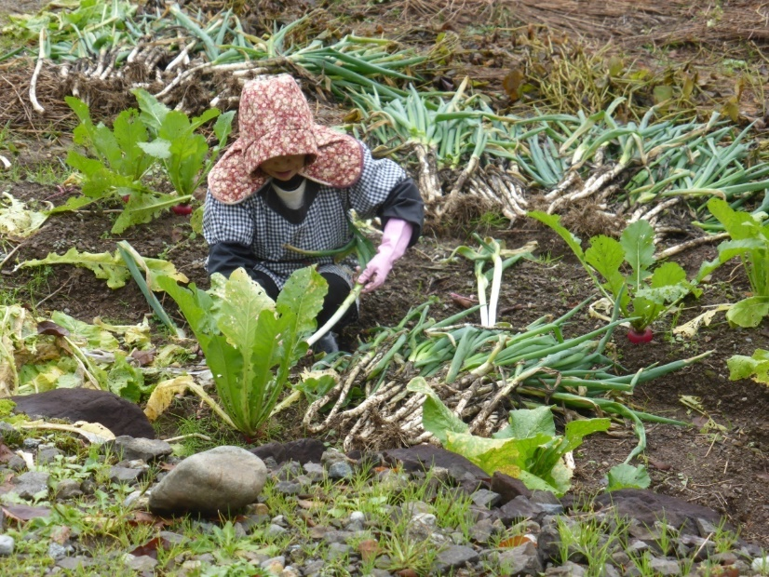
This villager was preparing for winter by picking the last of the crops, leeks and beetroots.

Hiroshima
Hiroshima was our next stop. This required a train trip of 5 ½ hours and included a journey on a wide-view train with picture windows.
Hiroshima was destroyed after the dropping of the Atomic Bomb during the Second World War. After the war, everything had to be rebuilt so the city looks quite new.
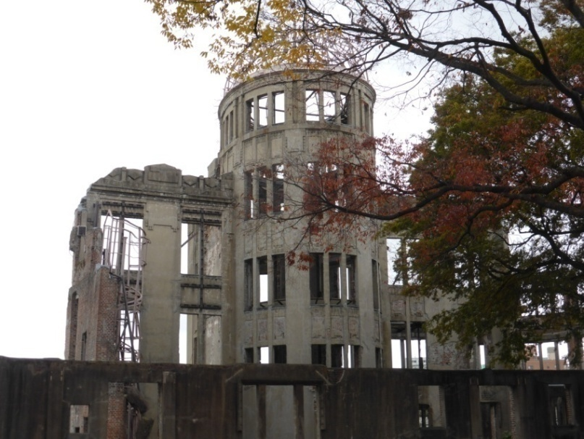
We expected to find the war memorial park very sobering and sad and it was. This park is where the atom bomb struck and killed everyone in and around it.
Hiroshima
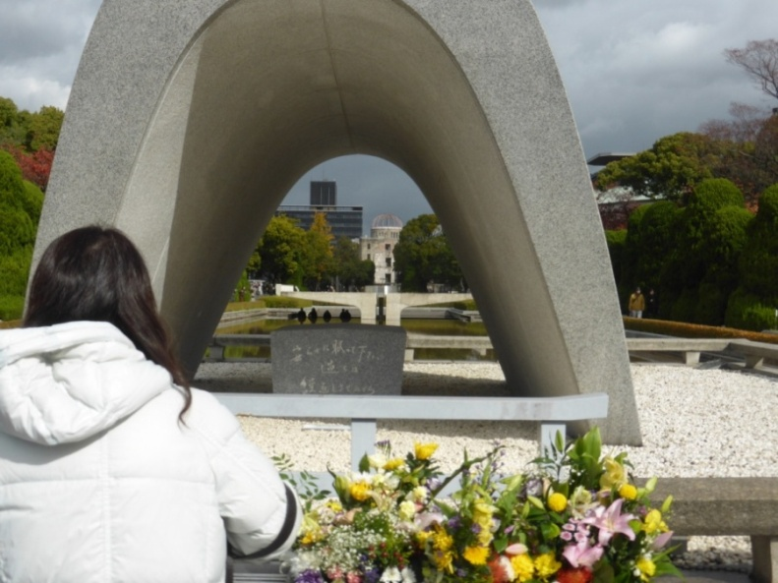
The cenotaph and eternal flame are very moving. In my photo, you can see a girl praying. Inside the war museum is the story of the bombing, all told in black and white photos. It is very graphic and poignant.
Miyajama
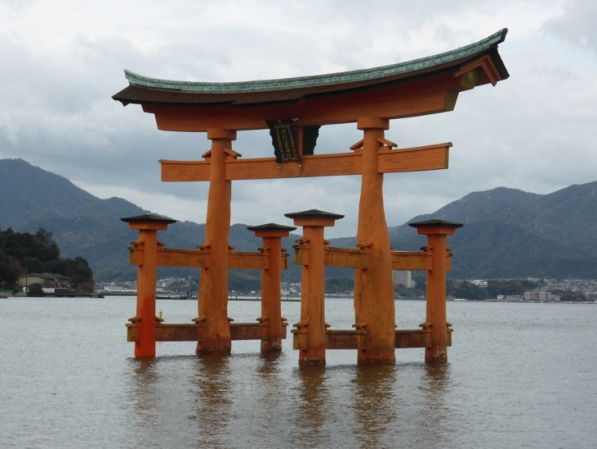
Miyajama is about an hour’s train ride from Hiroshima. It is a holy place of shrines and temples.

Due to the beauty of the sea and the mountains, I took lots of photos, including this wedding.
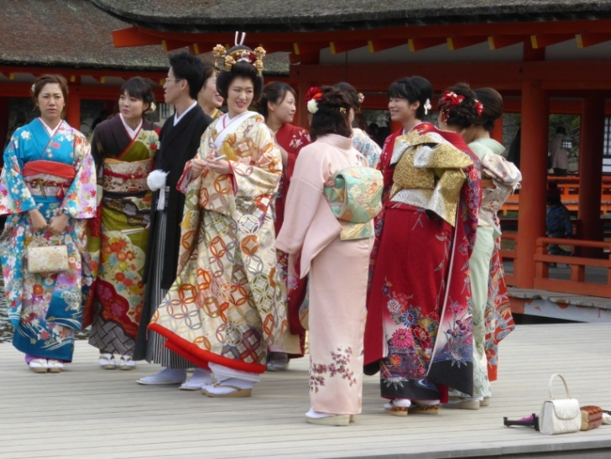
Miyajama
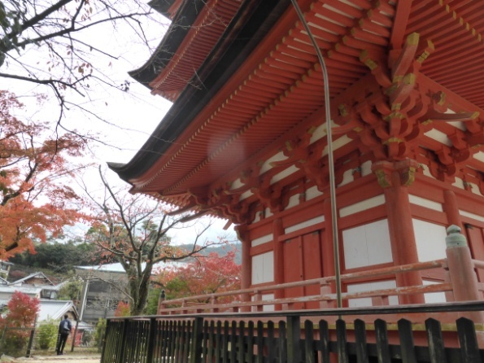
We climbed lots of steps to an orange pagoda and another shrine dedicated to rice gods.
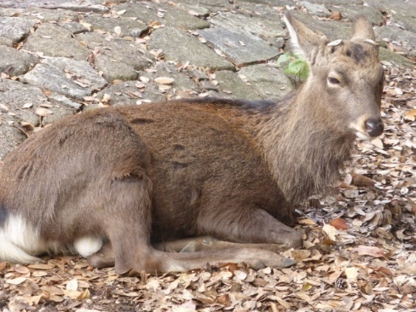

Wild, small deer roam freely.

Nara
Nara was a place we had visited before but we wanted to re-visit because it was so pretty and so interesting. To reach Nara, we took the train from Kyoto. Nara was the first capital of Japan. Deer roam freely here too.

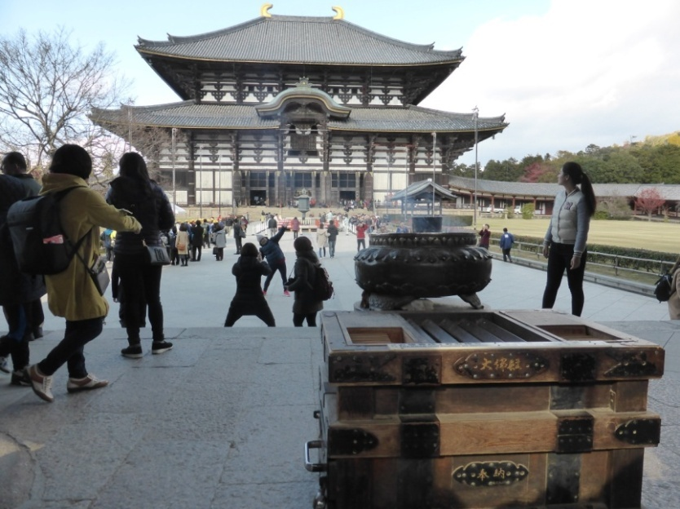
The Kasuga-Taisha Shrine was built in 768 BC and is UNESCO listed.

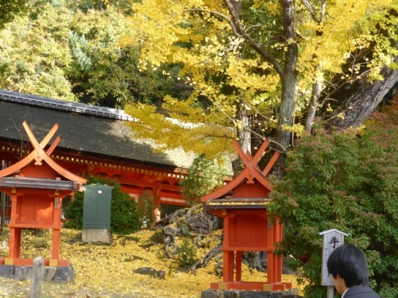

Nara
The Kasuga-Taisha shrine is famous for its bronze Buddha which is 15 metres high.

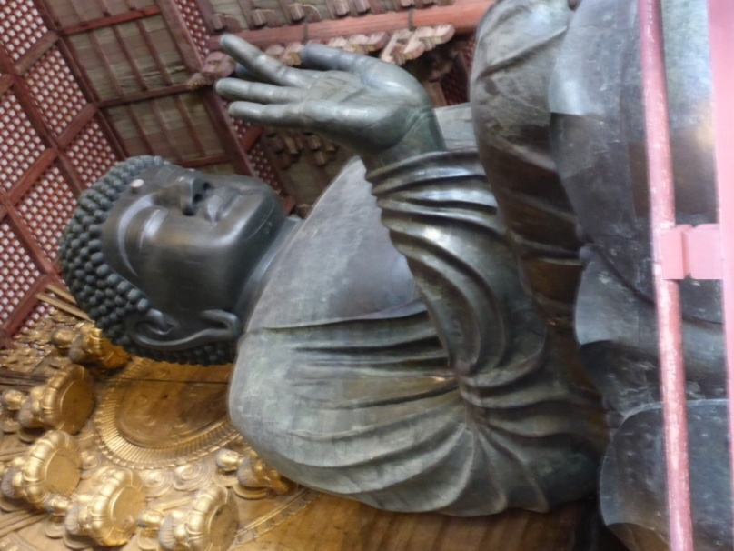

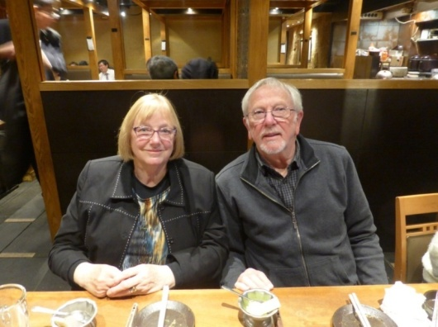
Dinner after an enjoyable but tiring day in Nara.

Kyoto – Inari Shrine
Kyoto was the imperial capital before 1868 when the royal household moved to Tokyo. It is a beautiful city and it was not bombed during World War 2.
One of the first things we did was to visit the Inari Shrine.
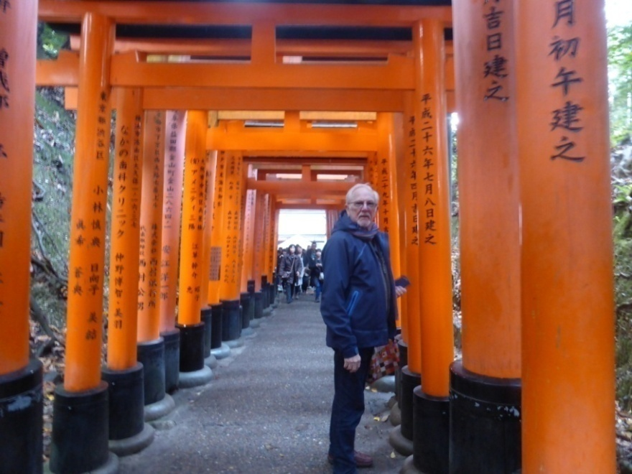
It consists of 10,000 vermillion gates leading up the mountain to the shrine.
When we visited, it was a public holiday and was quite crowded.
Kyoto – Inari Shrine
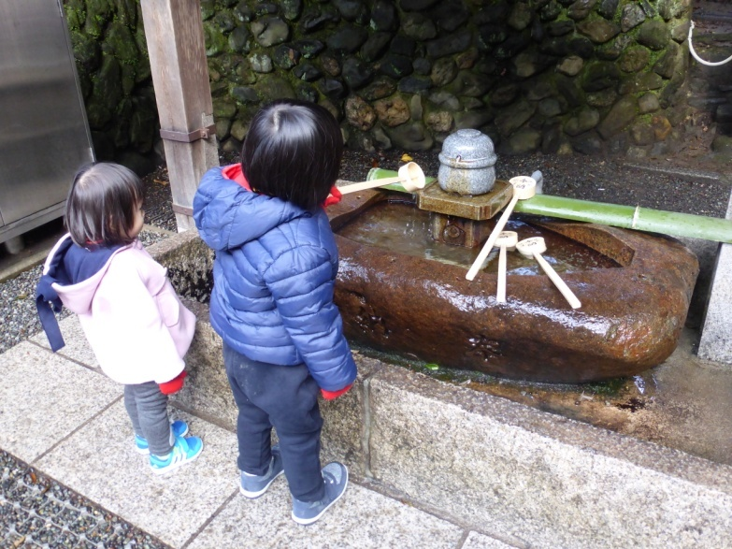
These children are blessing themselves by tipping holy water over their hands.

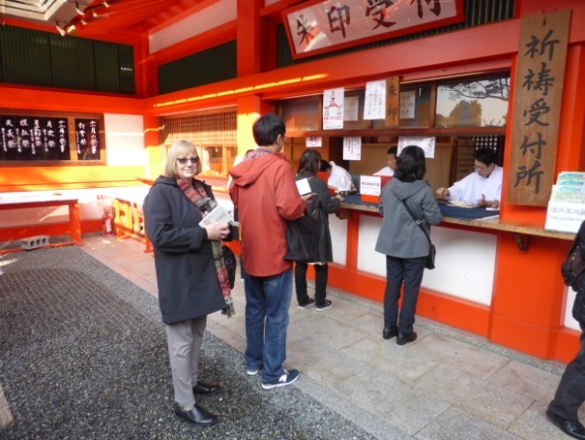
I am queuing to have the priest stamp my temple stamp book and give me a blessing. The blessings are for good luck and good health.
Kyoto
We decided to go rafting down the river through small ravines and over rapids.
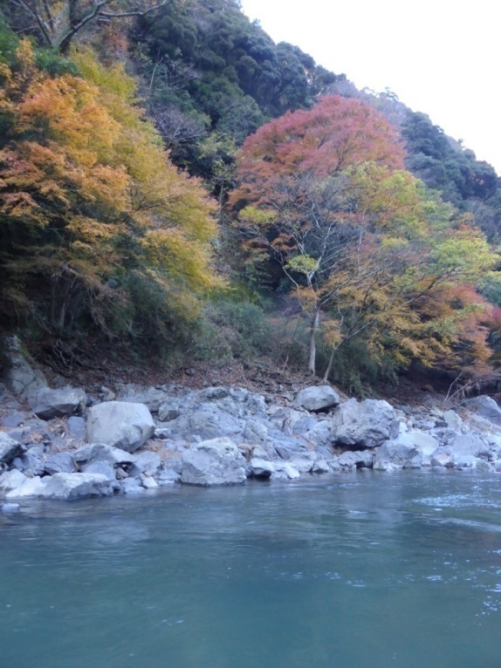
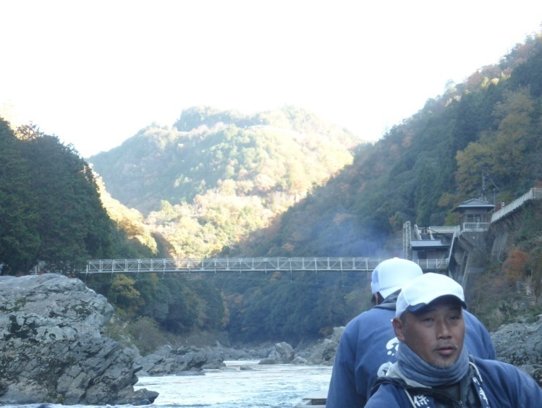
The men in the photo steered the boat with about twenty of us aboard. At times the rapids caused some fun and splashing but mostly the ride was about admiring the towering mountains & the tree covered ravines.
It was November and quite cold.
Kyoto
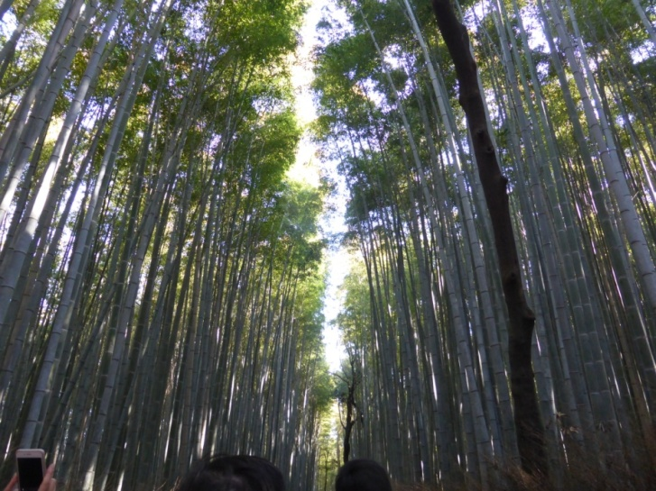
At the end of the boat ride we arrived at a giant bamboo grove. This grove was a very Imposing and majestic sight. We had never seen bamboo so tall.

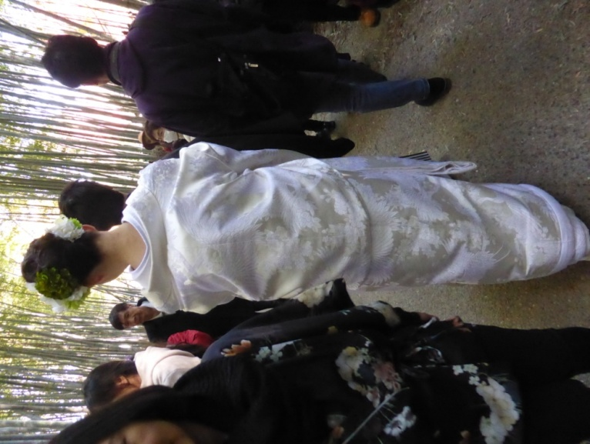
We saw a few brides tottering along on their stilt sandals trying to keep their outer cloak, worn over the kimono, from dragging along the dirt path.
Kyoto
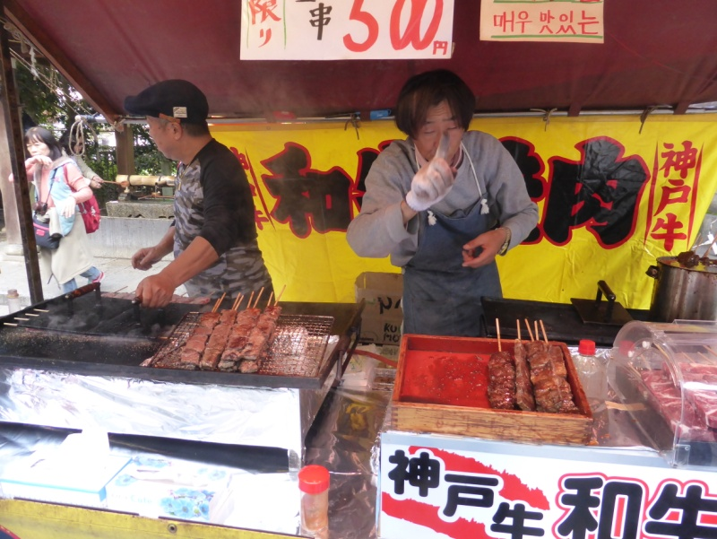
Our final day was spent in a market, held in the large gardens of a temple complex.

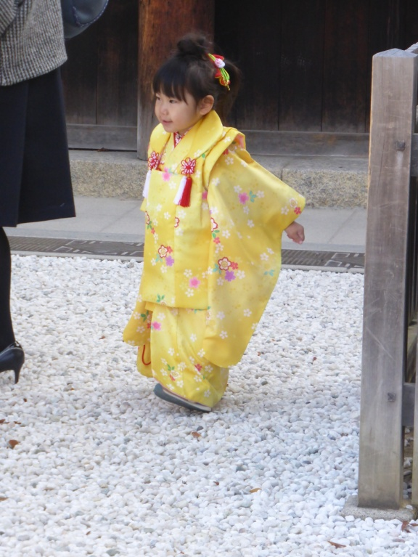
It was a weekend and families were out enjoying the activities. Many of the ladies and girls were dressed in traditional dress. It was a marvellous way to spend our last day of the trip; mixing with the locals.
Sayonara!
Japanese people are very friendly and helpful. Everywhere is extremely clean and we felt quite safe travelling by ourselves without a guide. The crime rate is very low.
We only speak a few words of Japanese. Outside the cities, very little English is spoken except by younger people. However, we managed with sign language and pointing and with people offering help!
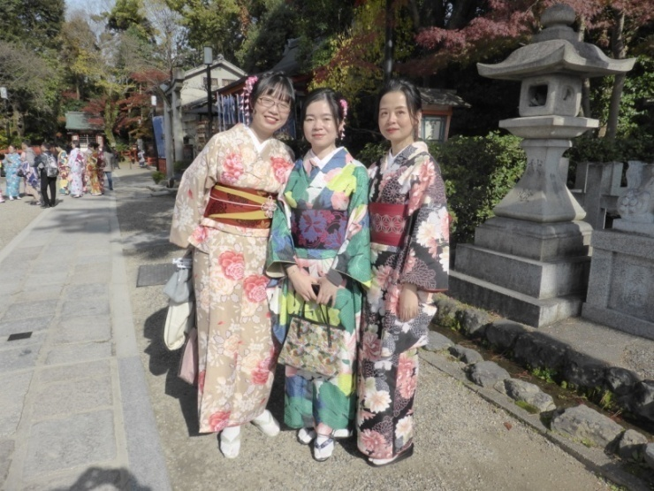
I hope you have enjoyed seeing some of the sights of Japan that we enjoyed on our train trip in 2017.

