Bella Italia Festivals: Quiz and Colouring book

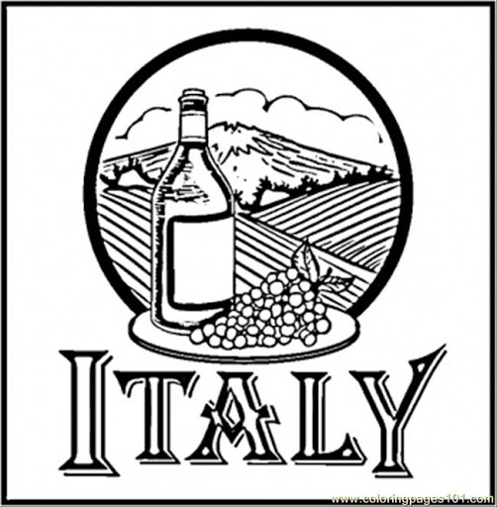

The Rotary Club of Canterbury “Let’s Stay Connected Project” has been developed as a response to an identified need within the Aged Care sector.
At times when it’s difficult to connect in person with family and friends, the Rotary Club of Canterbury has pleasure in offering you this booklet, designed to promote conversation, recollection and engagement for those who are in isolation and without their usual social activities.
The booklets have been designed for people in an aged care residence, village or at home to read by themselves, or to have a family or staff member share the booklet with them.
You can download this and other booklets from the Rotary Club of Canterbury website (www.canterburyrotary.org).
Source references for this book are held at the Rotary Club of Canterbury. Contact president@caterburyrotary.org for further details.
Material in this book was reproduced in accordance with Section 113F of the Copyright Act (1968).

Hi
My name is Val and I’m a member of the Rotary Club of Canterbury.

It’s been fun researching some of the famous festivals in Italy for you. It’s reminded me of time spent in Italy.
Kind regards
Val

Carnevale in Italy

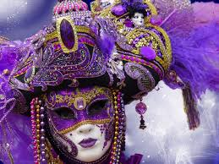

As the saying goes, “A Carnevale ogni scherzo vale.” When it’s carnival time, anything goes.

Q1. When is Carnevale held?

Q2. What is Carnevale about?

Q3. What special foods are eaten?

Carnevale in Italy
Q1. When is Carnevale held?
Carnevale is held in the weeks leading up to Easter. It finishes with a big final party the day before Ash Wednesday, on Shrove Tuesday.

Q2. What is Carnevale about?
Carnevale is the last opportunity to indulge before Lent is held, after which, from Ash Wednesday until Easter Sunday, many Italian Catholics don’t eat meat. The reasons for this fasting are to concentrate the mind on the life and death of Jesus; to reflect self-sacrifice as shown by Jesus in his forty days’ fasting before the crucifixion; and to abstain from luxury to show solidarity with the poor of the world.

Q3. What special foods are eaten?
In Italy each region has its own typical Carnevale pastries, but all of them have one thing in common: they are all fried seasonal treats and come from the Roman frictilia, deep-fried pastries prepared during ancient spring festivals.
In the Veneto region the special pastries, called crostoli, galani and frittelle, are served in pastry-shops, bakeries and cafés.
Carnevale in Italy
A mask for you to colour.
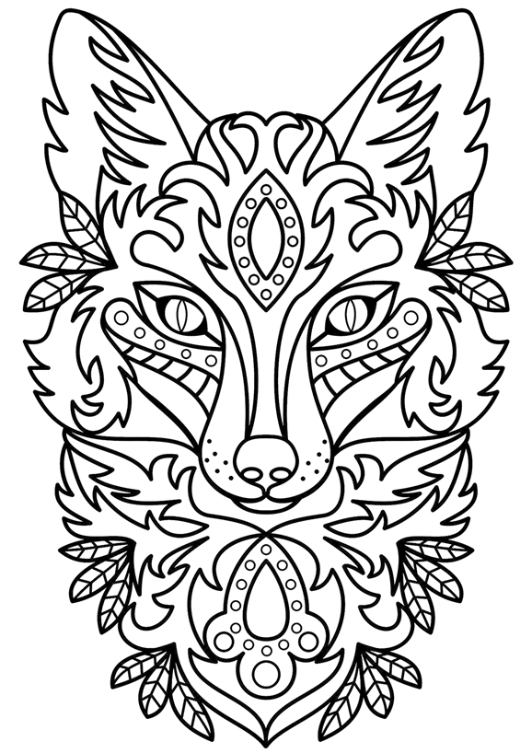
Palio delle Quattro Antiche
Repubbliche Marinare

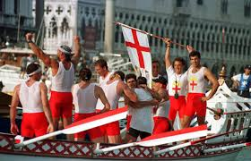

Q4. When is this festival held?

Q5. What is it about?

Q6. Where is this Festival held?

Palio delle Quattro Antiche
Repubbliche Marinare

Q4. When is this festival held?
This Festival is held every year on a day between the end of May and the beginning of July.

Q5. What is it about?
It is a sporting event of historical re-enactment, established in 1955 with the aim of recalling the rivalry of the most famous Italian maritime republics: those of Amalfi, Pisa, Genoa and Venice.
Four rowing crews representing each of the republics compete against each other. The regatta is preceded by an historical procession, through the streets of the organising city with figures that play the role of ancient characters that characterised each republic.

Q6. Where is this Festival held?
It is hosted in rotation between the four ancient rival maritime cities: Pisa, Venice, Amalfi, and Genoa.

Palio delle Quattro Antiche
Repubbliche Marinare

A gondolier and his gondola for you to colour

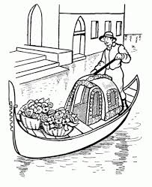

Il Palio

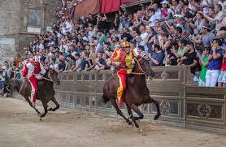

Q7. When is Il Palio held?

Q8. What is it about?

Q9. Where is it held?

Q10. Why is it dangerous?

Il Palio

Q7. When is Il Palio held?
The race takes place twice a year. The first occurs on the 2nd of July (Palio of Provenzano, in honour of the Madonna of Provenzano) and the second on the 16th of August (Palio of the Assumption, in honour of the Virgin Mary's Assumption).

Q8. What is it about?
The Palio is a passionate horse race in Siena, where the various "contrade", or areas in which the city is divided, challenge each other. Each Contrada has its own unique emblem and colours and represents an area of the city.

Q9. Where is it held?
In Piazza del Campo, Siena’s main medieval, shell-shaped square.

Q10. Why is it dangerous?
Because the horses run at full speed in the narrow city streets with bareback riders.

Il Palio
A horse for you to colour.

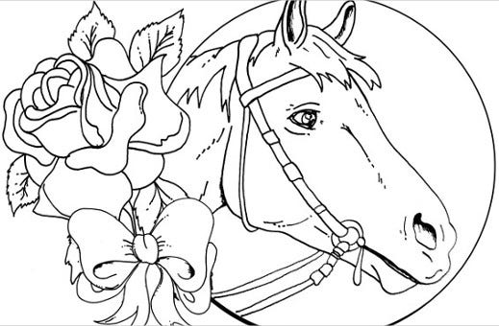

Flag Throwing in Tuscany
and Other Regions

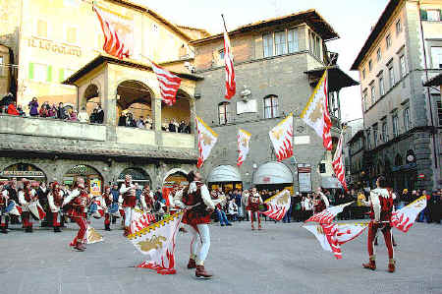

Flag throwing is often a major part of the historical costume festivals that are one of the great attractions of Tuscany and, indeed, of all Italy.

Q11. What is flag throwing?

Q12. What are the performers called?

Q13. What other countries participate in flag throwing?
Flag Throwing in Tuscany
and Other Regions

Q11. What is flag throwing?
The art of flag throwing dates back to medieval guilds. A guild's banner or flag was considered a symbol of purity, and as such it was not allowed to touch the ground.

Q12. What are the performers called?
The performers are known as sbandieratori and are usually young men but with an increasing number of young women taking part. They dress in mediaeval costume and are usually accompanied by drummers (tamburi) and sometimes also trumpeters (trombettieri).

Q13. What other countries participate in flag throwing events?
Although principally in Italy, other countries such as Germany and regions such as Flanders also participate in flag throwing festivals.

Flag Throwing in Tuscany
and Other Regions

Can you colour the Italian flag?

