The Richmond Football Club

The Rotary Club of Canterbury “Connecting in Isolation Project” has been specifically developed to support residents in aged care accommodation during the Covid-19 pandemic.
In times when it’s difficult to connect in person with family and friends, the Rotary Club of Canterbury has pleasure in offering you this booklet, designed to promote conversation, recollection and engagement to those who are in isolation and without their usual social activities.
The booklets have been designed for people in an aged care residence to read by themselves, or to colour in the pictures, or to have a family member at the other end of the phone read the booklet to them.
You can download this and other booklets from the Rotary Club of Canterbury website (www.canterburyrotary.org).
Source references for this book are held at the Rotary Club of Canterbury. Contact president@caterburyrotary.com.au for further details. Material in this book was reproduced in accordance with Section 113F of the Copyright Act (1968).

The Richmond Football Club

The nickname for the Richmond Football Club is the Tigers. The Club started in Richmond in 1885.

The Tigers won two premierships during the period 1885-1907 when they were part of the Victorian Football Association (VFA). In 1908, Richmond joined the Victorian Football League (VFL, later Australian Football League [AFL]) and has since won twelve premierships, the most recent being in 2019.
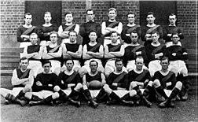

Richmond won its first premiership in 1920.
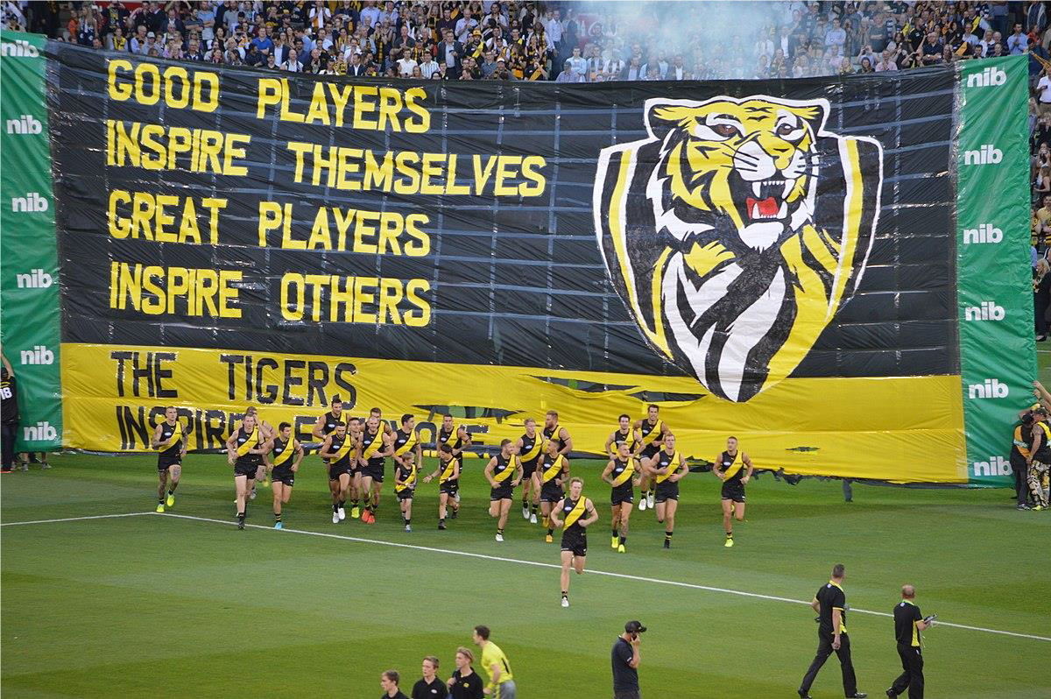
The Richmond players entering the ground in the 2018 Grand Final match against Carlton.

The AFL Premiership Cup 2019

Richmond’s home
Richmond’s headquarters and its training ground are at the Punt Road Oval which was its original home ground until the widening of Punt Road in 1965. The MCG (Melbourne Cricket Ground) is now the home ground for the Tigers.
There are now just over 100,000 members of the Richmond Football Club.

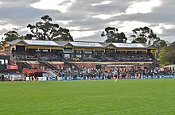
The Jack Dyer Stand at the Punt Road Oval.
The Richmond Uniform
The Tiger’s jumper has a distinctive yellow diagonal stripe on a black background and is worn for both home and away games. A yellow jumper with black diagonal is used when playing against another team with a similar style of uniform, such as Essendon with their red diagonal stripe on black.
Interesting Snippets

In 1896, Richmond walked off the field in a match against South Melbourne to protest the umpiring. Later that season, the Tigers had their half-time score annulled against Essendon when it was discovered they had too many men on the ground.

From 1927 to 1929 Richmond became the first club in the VFL to lose three consecutive Grand Finals, all of which were to neighbouring archrivals, Collingwood.

The highest score achieved by a Richmond team was 34 goals 18 behinds (222 points). This was in a game against St Kilda in 1980.

The lowest score recorded by Richmond was 8 behinds (8 points) against St Kilda in 1961.
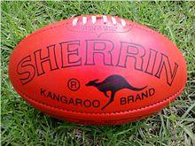

Questions
- Where you a football fanatic?

- How often did you go to the football?

- Did you go to watch Richmond play?

- What games can you remember? Who were they playing against?

Australian Football Hall of Fame

The AFL has put together a Football Hall of Fame. Past players are considered on the basis of their ability, integrity, sportsmanship and character. While the number of games played is a consideration, it alone does not determine eligibility.

There is a special subset within the Hall of Fame, the "Legend" which is the highest honour which can be bestowed on an Australian footballer. The Legends category is reserved for those who are deemed to have had a significant impact on the game of Australian rules football.

Five of the 29 Legends listed were Richmond players. They are Kevin Bartlett, Jack Dyer, Royce Hart, Kevin Sheedy and Ian Stewart.

Can you recognise these Richmond Legends?
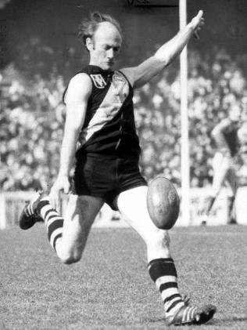
1

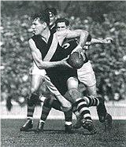

2

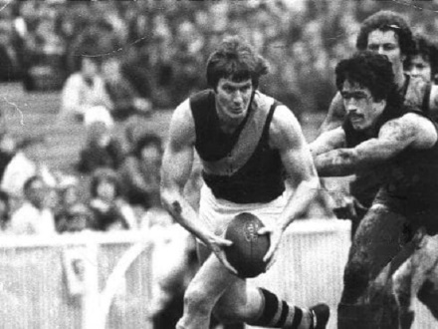
3

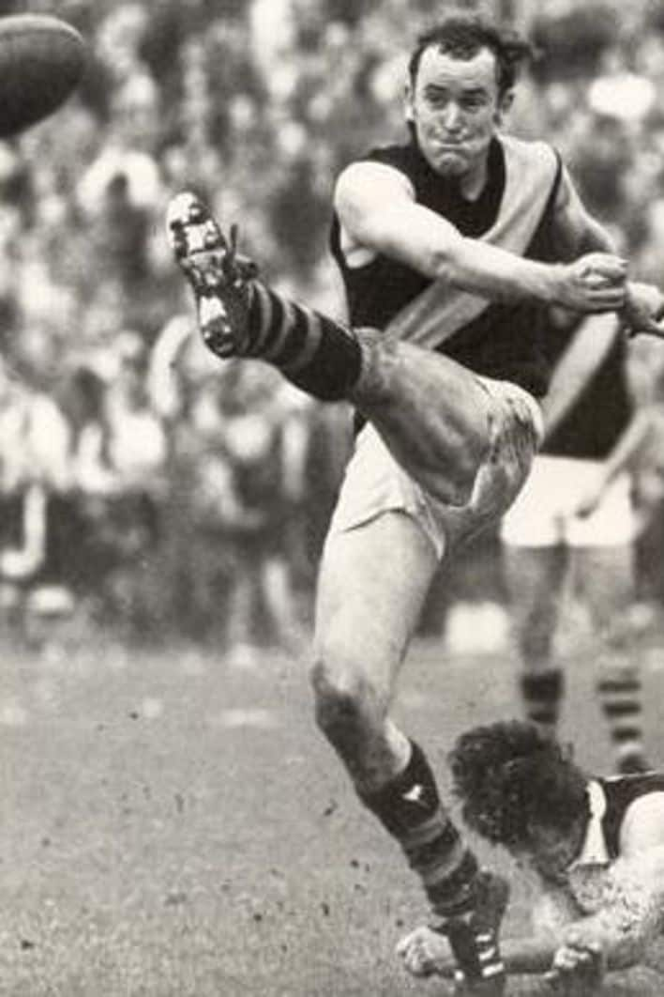

4

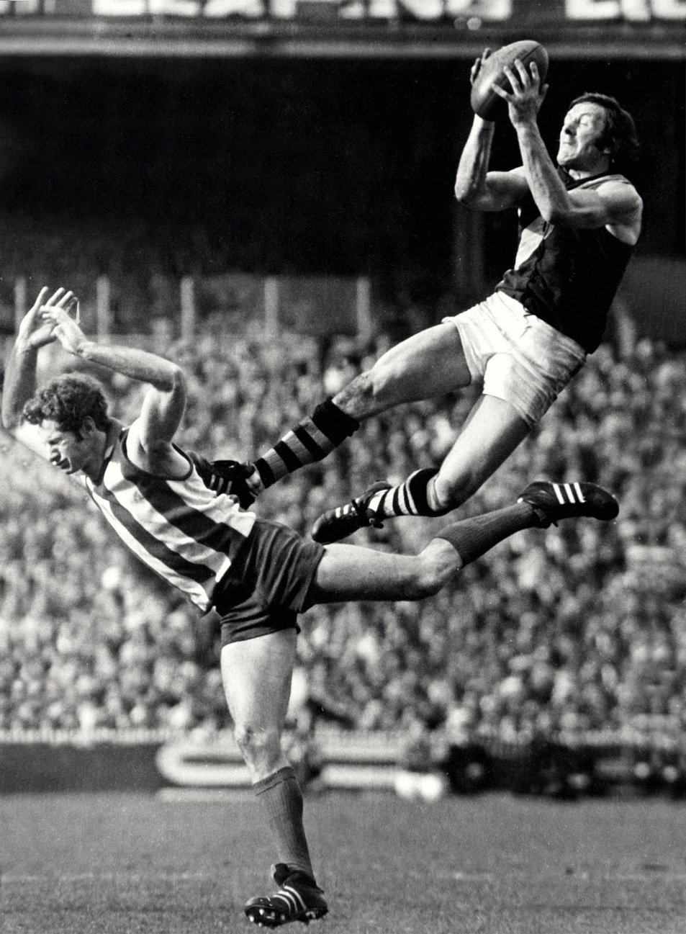
5

This footballer was not known for his marking prowess, but this grab over North Melbourne's Gary Farrant in the 1974 Grand Final is seen as one of the top 10 Tiger Marks of the Century.

- Kevin Bartlett

Kevin played for the Richmond Football Club between 1965 and 1983.

He played 403 games in total. This is the third highest number of games in VFL/AFL history. He won five premierships with Richmond and won their best and fairest medal five times.

Bartlett was a rover and goalkicker who was known as 'Hungry' due to his preference for kicking rather than handballing. He kicked a total of 778 goals for Richmond and was their leading goal kicker in 1974, 1975, 1977 and in 1983, his last year of playing football.

He coached Richmond from 1988-1991.

- Jack Dyer (Captain Blood)

Jack played for the Richmond Football Club from 1931-1949.

Jack played 19 consecutive seasons for the club, playing 312 games and scoring 443 goals. He was voted the club’s best and fairest six times. He also coached the team to a VFL premiership in 1943 as Captain-Coach.

After a number of on field incidents and after a particularly difficult game in 1935, a newspaper cartoonist drew a picture of Dyer as a pirate and a journalist nicknamed him ‘Captain Blood’, after the Errol Flynn film Captain Blood.

- Royce Hart
Royce played for the Richmond Football Club from 1967-77. He was born in Tasmania and came to Richmond’s attention as a 16-year old. Richmond signed him on sight unseen. Legend has it that his sign-on fee was a suit and six shirts. What a bargain!

At age 17, Royce moved to Melbourne to play for the Richmond under-19s. The next year, he was playing with the senior team.

Royce played 188 games, kicking 369 goals. He captained Richmond from 1972-75; played in four grand final premiership teams and won Richmond’s best and fairest award twice.

The AFL ‘Team of the Century’ named him as its centre half-forward due to his remarkable marking skills, and penetrating left-foot kick.
Ian Stewart

Ian Stewart is another player from Tasmania. His early football career was with St Kilda where he played in the only winning St Kilda premiership side, an act he replicated at Richmond.

In 1970, being disenchanted with St Kilda he approached Richmond seeking a transfer. While transfers are common nowadays, it was unusual for the time. Richmond traded Billy Barrot for Stewart. Stewart went on to play 78 games for Richmond, kicking 55 goals. He is one of four men to win the Brownlow Medal three times and the only one to win while playing at different clubs.

- Kevin Sheedy

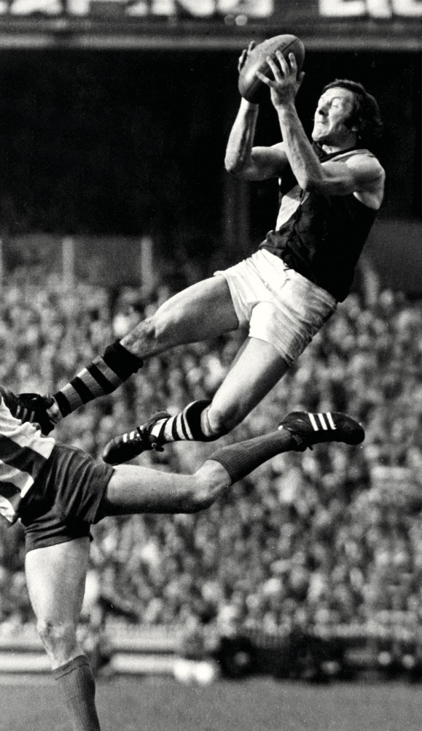
Kevin Sheedy played for the Richmond Football Club between 1967-79. He is Melbourne born and bred and played exclusively for Richmond in the VFL. He retired from playing to take up coaching.

He played and coached in a combined record total of 929 games over 47 years (1967-2013).

In his early career, he was seen as the best back-pocket player in the VFL, later moving to the ruck rover where he starred.

He went on to coach several premiership teams and has work to encourage young Indigenous people to take up the game.
Questions
- Did you ever see any of these Richmond Legends play?

- Can you recall any exciting moments from their games?

- Do any of the current crop of Richmond players have the potential to become an AFL Legend?

Richmond Football Club Song

This song is usually sung at the end of a game when Richmond win. Sing along if you can.

Oh we’re from Tigerland
A fighting fury
We’re from Tigerland
In any weather
You will see us with a grin
Risking head and shin
If we’re behind then never mind
We’ll fight and fight and win
For we’re from Tigerland
We never weaken ‘til the final siren’s gone Like Tiger of old
We’re strong and we’re bold
For we’re from Tiger
Yellow and Black
We’re from Tigerland.

Can you see this song?

